GITHUB EXERCISE -1

- TO CHECK IF GIT CLIENT IS INSTALLED PROPERLY: OPEN GIT BASH SHELL AND EXECUTE

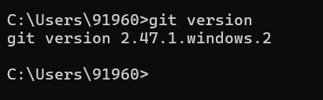T
- TO CONFIGURE USER LEVEL CONFIGURATION OF USER ID AND EMAIL ID EXECUTE
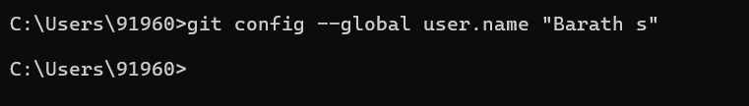

- TO CHECK IF THE CONFIGURATION IS PROPERLY SET, EXECUTE THE FOLLOWING COMMAND.
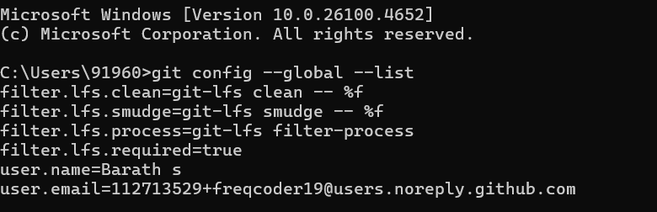

- INTEGRATE NOTEPAD++.EXE TO GIT AND MAKE IT A DEFAULT EDITOR
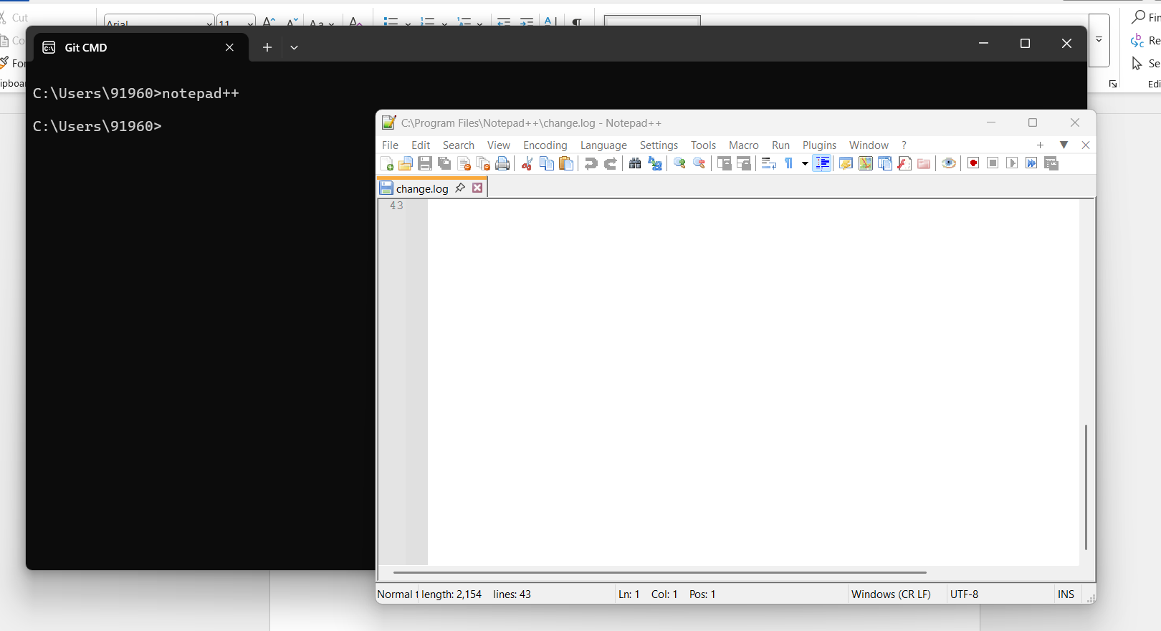

- TO CONFIGURE THE EDITOR, EXECUTE THE COMMAND
- TO VERIFY IF NOTEPAD++ IS THE DEFAULT EDITOR, EXECUTE THE COMMAND
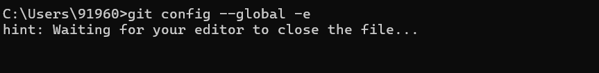
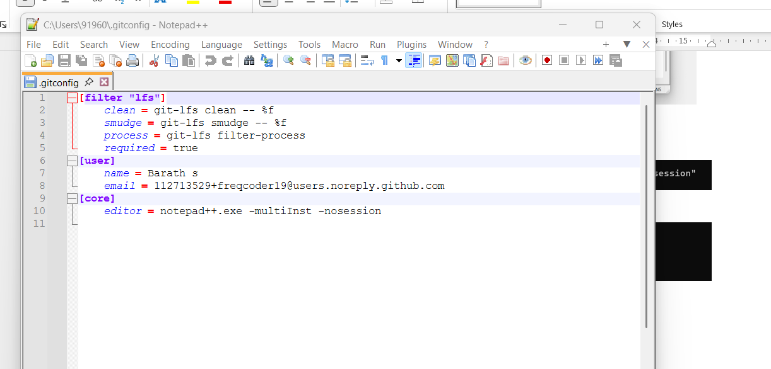

- ADD A FILE TO SOURCE CODE REPOSITORY
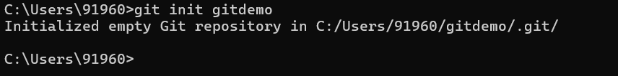
- TO VERIFY THE CONTENT, EXECUTE THE COMMAND
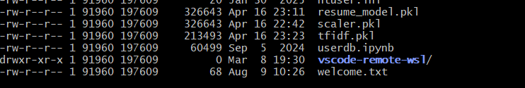
- TO VERIFY THE CONTENT, EXECUTE THE COMMAND
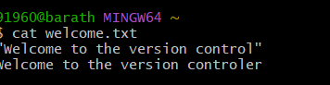
- CHECK THE STATUS BY EXECUTING
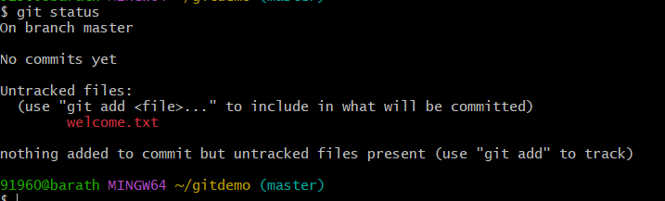

- TO MAKE THE FILE TO BE TRACKED BY GIT REPOSITORY, EXECUTE THE COMMAND
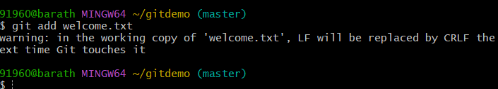

- TO ADD MULTI LINE COMMENTS, WE ARE OPENING DEFAULT EDITOR TO COMMENT. EXECUTE THE COMMAND

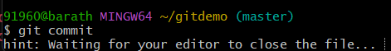

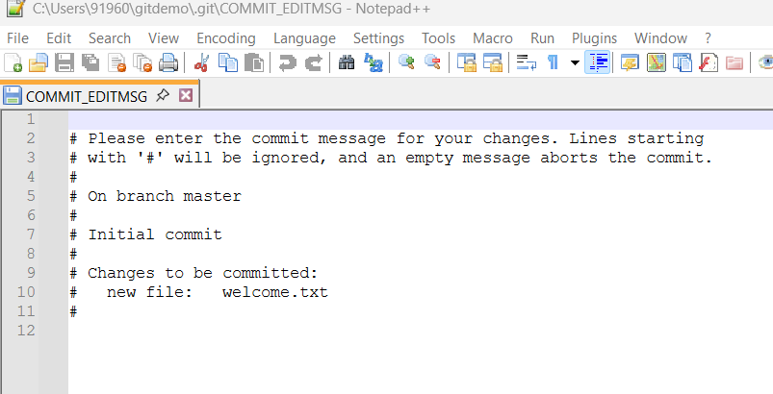

- TO CHECK IF LOCAL AND “WORKING DIRECTORY” GIT REPOSITORY ARE SAME, EXECUTE GIT STATUS

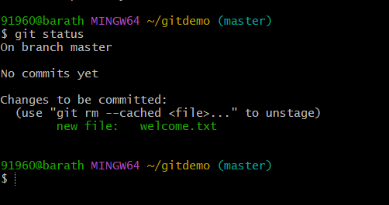

GITHUB EXERCISE -2
- First we need to ensure the git demo directory is present

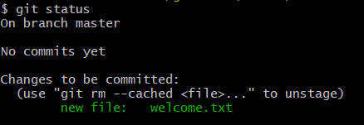
- Then we need to create a log folder and log file
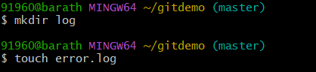
- We need to create an gitignore file
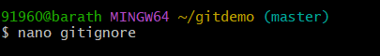
- We need to type and save below two commands

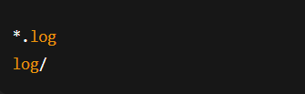

- Save the file check status
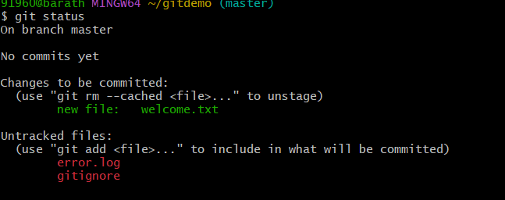

- Now we add the gitignore file add add the log values to repository and mention clearly that these values to be ignore
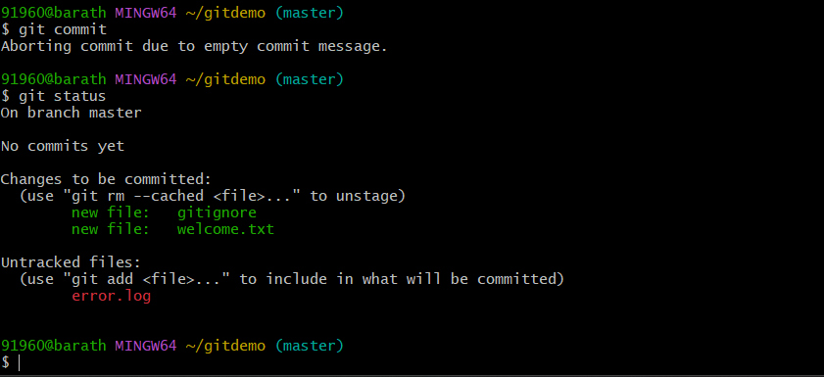

GITHUB EXERCISE -3

1 ) we create a new repository
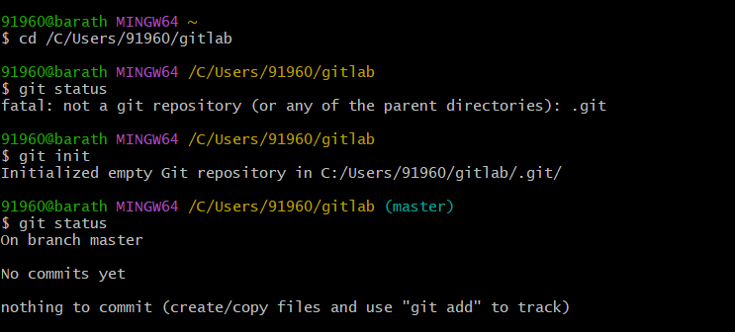

2) We need atleast one file or folder to create a branch in the repository we can’t do it in a empty repository so we add some files for branching purpose

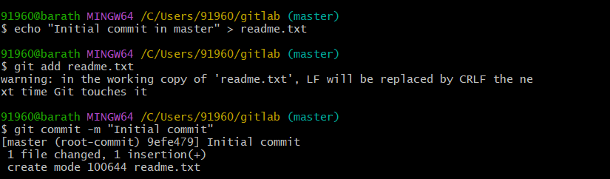

3) create a new branch
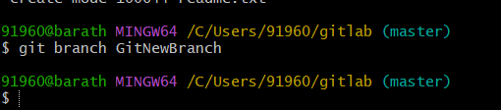

4) changing the file to new branch
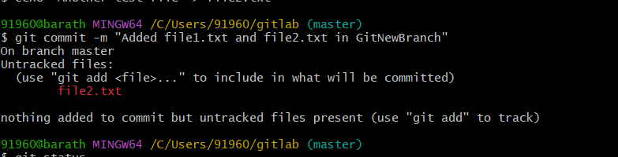

5) checking the git status after branching
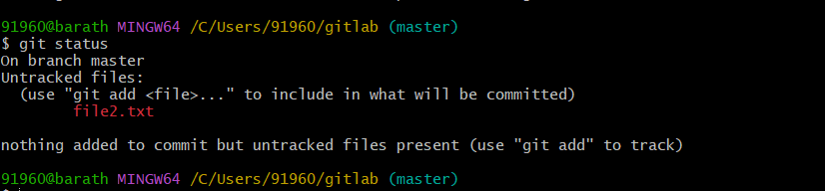

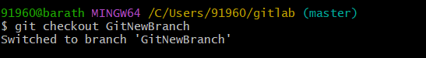

MERGING THE BRANCHES

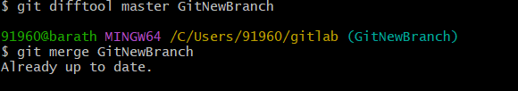

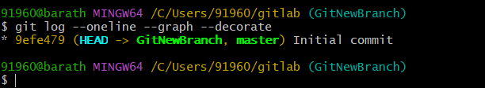

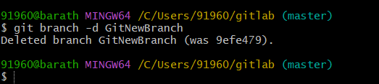
Deleting a branch

GITHUB EXERCISE -4

- Verify if master is in clean state.
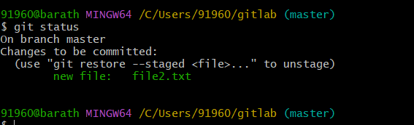

- Create a branch “GitWork”. Add a file “hello.xml”.
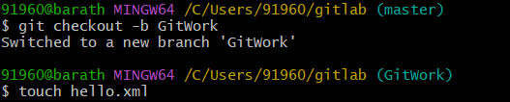

- Update the content of “hello.xml” and observe the status
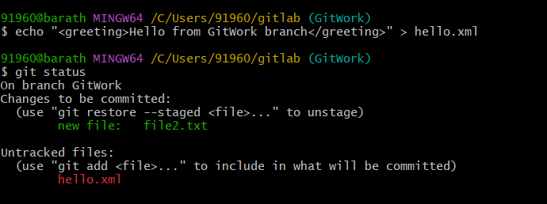
- git commit -m "Added hello.xml in GitWork branch"
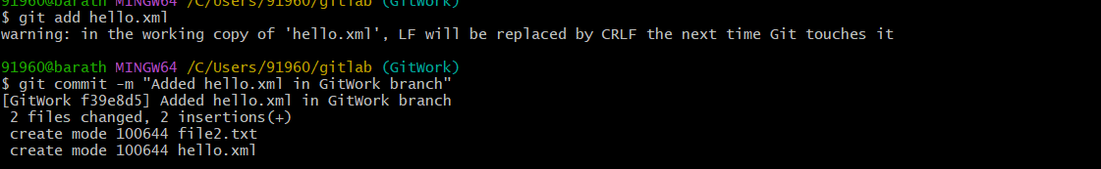

- switch to master
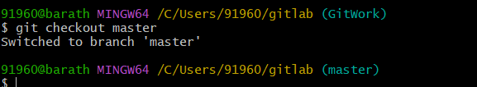

- Add a file “hello.xml” to the master and add some different content than previous.
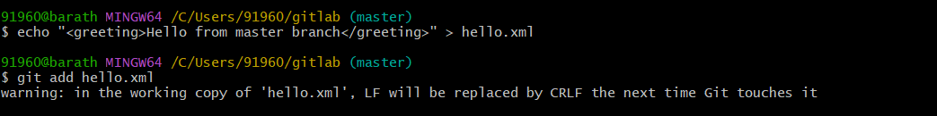

- Observe the log by executing “git log –oneline –graph –decorate –all”
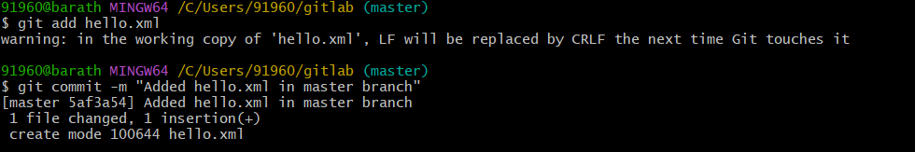

- Observe the log by executing “git log –oneline –graph –decorate –all”

- Check the differences with Git diff tool
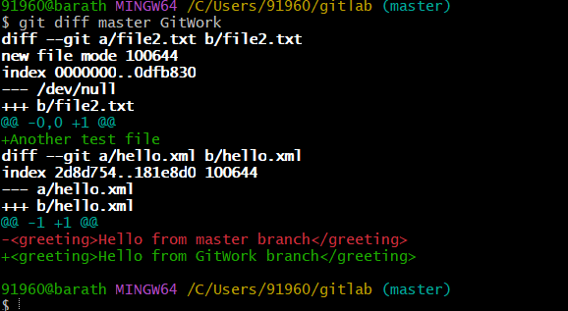

- For better visualization, use P4Merge tool to list out all the differences between master and branch
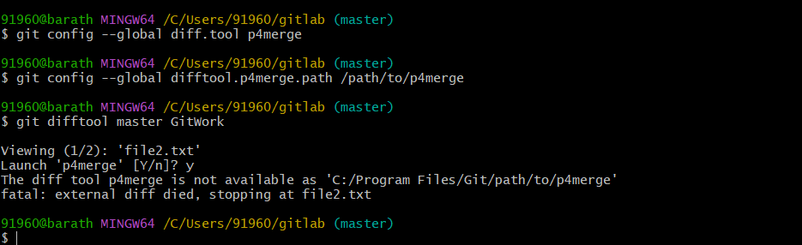

- Merge the bran to the master
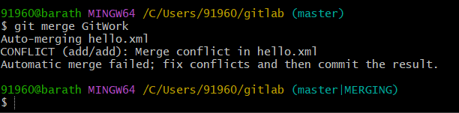

- Observe the git mark up.

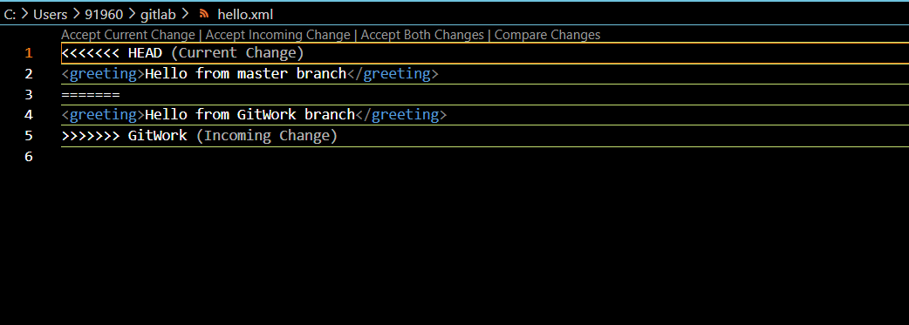

- Use 3-way merge tool to resolve the conflict
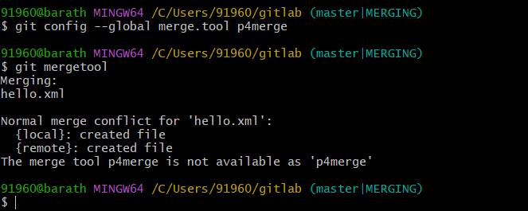

- Commit the changes to the master, once done with conflict
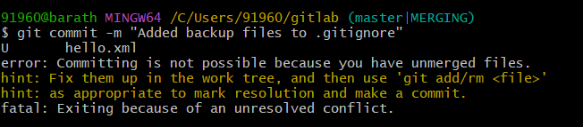

- 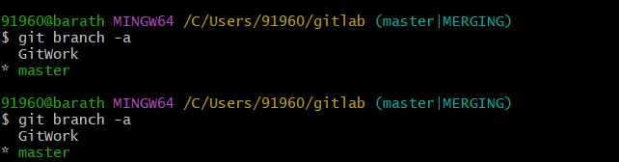

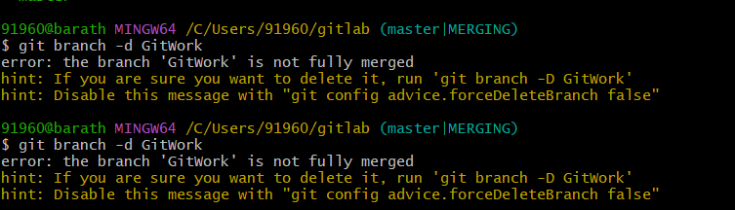

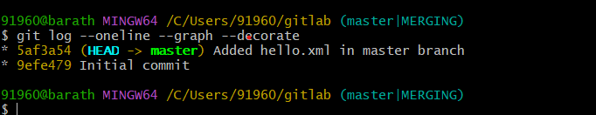
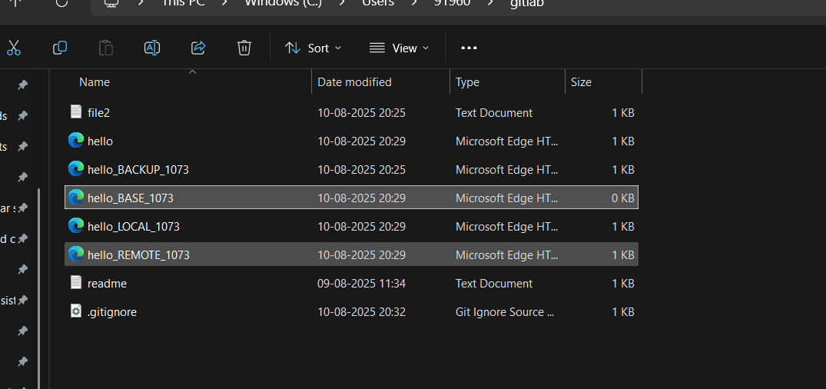

GITHUB EXERCISE -5
- Check status
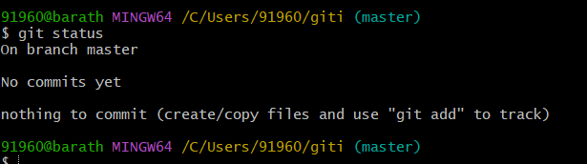

- List out all the available branches.
